UNIT 4
Cloud Computing and Internet of Things (IOT)

4.1 Cloud computing definition
Due to increased number of users, and increased complexity of software systems, demand for hardware resources like processors, memory, storage, network, database, software and other services has also been increased. In order to address this demand, companies like Amazon, Microsoft, Google, etc. are providing very large server farms and data centers over the Internet to multiple customers, who pay only for the resources they use. Because organizations using public clouds do not own the infrastructure, they don’t have to make large investment in their own hardware and software. Public clouds are ideal for small and medium-s ized businesses who can’t afford to fully develop their own infrastructure; for applications requiring high performance, scalability, and availability.
Companies offering these computing services are called cloud providers and typically charge for cloud computing services based on usage, similar to how we paid the bill for water, electricity, telephone at home. Some of the cloud providers are Amazon AWS, Microsoft Azure, Google Cloud, IBM Cloud, VMware Cloud, Oracle Cloud and Alibaba Cloud. You are probably using cloud computing right now, even if you don’t realize it. If you use an online service to send an email, edit documents, watch movies or TV, listen to music, play games or store pictures and other files, it is likely that cloud computing is making it all possible behind the scenes.
Cloud Computing is defined as storing and accessing of data and computing services over the internet. It doesn’t store any data on your personal computer. It is the on-demand availability of computer services like servers, data storage, networking, databases, etc. The main purpose of cloud computing is to give access to data centers to many users. Users can also access data from a remote server. Examples are Microsoft office 365, Google drive, Apple icloud etc.
Here are a few of the things you can do with the cloud
- Create new apps and services,
- Store, back up and recover data,
- Host websites and blogs,
- Stream audio and video,
- Deliver software on demand.

4.2 Features and Components of cloud computing

4.2.1 Features of cloud computing
The features of cloud computing are as follows:
1. On-demand Self-Service
It is one of the important and valuable features of Cloud Computing as the user can continuously monitor the server uptime, capabilities, and allotted network storage. With this feature, the user can also monitor the computing capabilities.
2. Easy Maintenance
The servers are easily maintained and the downtime is very low and even in some cases, there is no downtime. Cloud Computing comes up with an update every time by gradually making it better. The updates are more compatible with the devices and perform faster than older ones along with the bugs which are fixed.
3. Large Network Access
The user can access the data of the cloud or upload the data to the cloud from anywhere just with the help of a device and an internet connection. These capabilities are available all over the network and accessed with the help of internet.
4. Availability
The capabilities of the Cloud can be modified as per the use and can be extended a lot. It analyzes the storage usage and allows the user to buy extra Cloud storage if needed for a very small amount.
5. Automatic System
Cloud computing automatically analyzes the data needed and supports a metering capability at some level of services. We can monitor, control, and report the usage. It will provide transparency for the host as well as the customer.
6. Economical
It is the one-time investment as the company (host) has to buy the storage and a small part of it can be provided to the many companies which save the host from monthly or yearly costs. Only the amount which is spent is on the basic maintenance and a few more expenses which are very less.
7. Security
Cloud Security, is one of the best features of cloud computing. It creates a snapshot of the data stored so that the data may not get lost even if one of the servers gets damaged. The data is stored within the storage devices, which cannot be hacked and utilized by any other person. The storage service is quick and reliable.
8. Pay as you go
In cloud computing, the user has to pay only for the service or the space they have utilized. There is no hidden or extra charge which is to be paid. The service is economical and most of the time some space is allotted for free.

4.2.2 Component of cloud computing
Here are some important components of Cloud computing architecture:
1. Client Infrastructure:
Client Infrastructure is a front-end component that provides a GUI. It helps users to interact with the Cloud.
2. Application:
The application can be any software or platform which a client wants to access.
3. Service:
The service component manages which type of service you can access according to the client’s requirements.
Three Cloud computing services are:
Software as a Service (SaaS)
Platform as a Service (PaaS)
Infrastructure as a Service (IaaS)
4. Runtime Cloud:
Runtime cloud offers the execution and runtime environment to the virtual machines.
5. Storage:
Storage is another important Cloud computing architecture component. It provides a large amount of storage capacity in the Cloud to store and manage data. In cloud storage, the data can be accessible to multiple clients simultaneously.
6. Infrastructure:
It offers services on the host level, network level, and application level. Cloud infrastructure includes hardware and software components like servers, storage, network devices, virtualization software, and various other storage resources that are needed to support the cloud computing model.
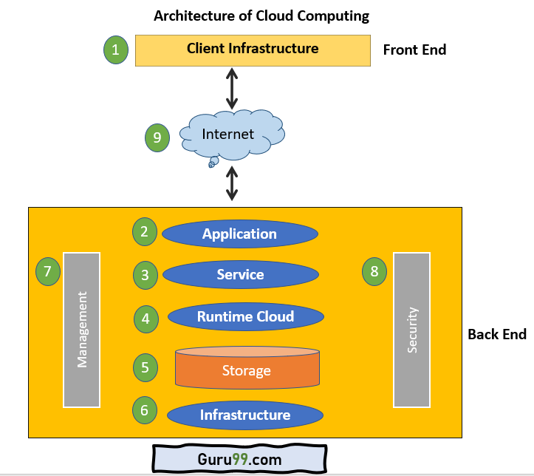
FIGURE: Architecture of cloud computing
7. Management:
This component manages components like application, service, runtime cloud, storage, infrastructure, and other security matters in the backend. It also establishes coordination between them.
8. Security:
Security in the backend refers to implementing different security mechanisms for secure Cloud systems, resources, files, and infrastructure to the end-user.
9. Internet:
Internet connection acts as the bridge or medium between frontend and backend. It allows you to establish the interaction and communication between the frontend and backend.

4.3 classification of cloud computing

4.3.1 Types of Cloud computing
There are four main types of cloud computing:
- Public clouds,
- Private clouds,
- Hybrid clouds, and
- Community clouds.
- Public clouds
Public clouds are cloud environments typically created from IT infrastructure not owned by the end user. Some of the largest public cloud providers include Alibaba Cloud, Amazon Web Services (AWS), Google Cloud, IBM Cloud, and Microsoft Azure.
All clouds become public clouds when the environments are partitioned (divided) and redistributed to multiple tenants (renters). Fee structures aren't necessary characteristics of public clouds anymore, since some cloud providers (like the Massachusetts Open Cloud) allow tenants to use their clouds for free. The bare-metal IT infrastructure used by public cloud providers can also be abstracted and sold as IaaS, or it can be developed into a cloud platform sold as PaaS.
- Private clouds
Private clouds are loosely defined as cloud environments solely dedicated to a single end user or group, where the environment usually runs behind that user or group's firewall. All clouds become private clouds when the underlying IT infrastructure is dedicated to a single customer with completely isolated access. But private clouds no longer have to be sourced from on-premise IT infrastructure. Organizations are now building private clouds on rented, vendor-owned data centers located off-premises, which makes any location and ownership rules obsolete (out-of-date).
- Hybrid clouds
A hybrid cloud is a seemingly single IT environment created from multiple environments connected through local area networks (LANs), wide area networks (WANs), virtual private networks (VPNs), and/or APIs. The characteristics of hybrid clouds are complex and the requirements can differ, depending on whom you ask. For example, a hybrid cloud may need to include at least one private cloud and at least one public cloud.
But every IT system becomes a hybrid cloud when apps can move in and out of multiple environments yet connected with each other. And all those environments need to be managed as a single environment using an integrated management and orchestration platform.
- Community Cloud
Community cloud allows systems and services to be accessible by a group of several organizations to share the information between the organization and a specific community. It is owned, managed, and operated by one or more organizations in the community, a third party, or a combination of them. E.g. Health Care community cloud.

4.3.2 Types of cloud computing services
There are also three main types of cloud computing services:
- Infrastructure-as-a-Service (IaaS),
- Platforms-as-a-Service (PaaS), and
- Software-as-a-Service (SaaS).
1. Infrastructure as a Service (IaaS):
In this type of cloud service, customer can use processing, storage, networking, and other computing resources from cloud service providers to run their software system. Customers are billed according to the usages of computing power and storage.
IaaS manages the infrastructure for you—the actual servers, network, virtualization, and data storage—through an internet connection. The user has access through an API or dashboard, and essentially rents the infrastructure. The user manages things like the operating system, apps, and middleware while the service provider takes care of any hardware, networking, hard drives, data storage, and servers; and has the responsibility of taking care of outages, repairs, and hardware issues. This is the typical deployment model of cloud storage providers.
2. Software as a Service (SaaS):
SaaS is a service that delivers a software application—which the cloud service provider manages—to its users. Typically, SaaS apps are web applications or mobile apps that users can access via a web browser. Customer subscribes the software services from a vendor for an annual subscription fee or sometimes free and use it over Internet. Services like Gmail, Google Drive, Salesfore.com - very popular Customer Relationship Management Software (CRM), Office 365 are some of the examples of SaaS. Software updates, bug fixes, and other general software maintenance are taken care of for the user, and they connect to the cloud applications via a dashboard or API. SaaS also eliminates the need to have an app installed locally on each individual user’s computer, allowing greater methods of group or team access to the software.
3. Platform as a Service (PaaS):
PaaS means the hardware and an application-software platform are provided and managed by an outside cloud service provider, but the user handles the apps running on top of the platform and the data the app relies on. Customer use infrastructure and programming tools and environment supported by the vendors to develop their own applications. IBM provides Bluemix for software development and testing on its cloud. Primarily for developers and programmers, PaaS gives users a shared cloud platform for application development and management without having to build and maintain the infrastructure usually associated with the process.

Scope of cloud computing in Nepal
The IT sector is an emerging area in Nepal. The Government of Nepal has identified IT and business process outsourcing (BPO) as one of the 5 priority potential export service sectors in the Nepal Trade Integration Strategy (NTIS) 2010. IT has the potential to generate high growth, investment, and significant profits in the coming years and is expected to be one of the most significant growth contributors to the Nepali economy. Business documents and data are very much important for every size of business. As we all know that world is progressing in the field of technology. We also accept that technology has improved almost everything which we use in our daily life and it also has provided us the strong fencing to secure our most important data and documents to get from loss.
Government Integrated Data Center (GIDC) is an international standard Government’s Data centers operated through National Information Technology Center (NITC). GIDC (Government Integrated Data Center) began offering types of assistance to just government associations in 2009. At first, GIDC was giving just Webhosting, email facilitating & worker co-area services. At present, GIDC is demonstrating cloud services to many government associations. The kind of cloud services given by GIDC is generally IaaS & PaaS. Data Hub is an international standard web Data Center in Nepal. It offers types of assistance like co-area services, data & organization security, catastrophe recuperation (recovery). It is situated in Thapathali, Kathmandu. Data Hub has almost a decade of experience providing co-location, hosting, and premium data-center services. Trusted by leading Nepali brands like Nepal Life Insurance, eSewa, Global IME Bank, Khalti, Subisu, Fone-pay, merojob, Vianet, and many other trusted companies.
Through, cloud service, we can easily share our data through the secure network to anyone we want. There are many possibilities to share our data without any fear to anyone by sharing the relevant link to the concerned person. It will save the data from any type of malware and nobody can enter our privacy lounge without authentication.
Therefore, cloud computing services has huge opportunity in Nepal market due to the large number of small and medium businesses. Most of the leading companies are already on cloud. Distance learning to remote areas and schools Benefit to SME (small and medium-sized enterprises) and corporate house increasing trend of out sourcing jobs. I believe, as soon as internet access is good, cloud computing in Nepal will develop in a similar manner to the World as a whole.

4.5 IoT and its features
The internet of things, or IoT, is a system of interrelated computing devices, mechanical and digital machines, objects, animals or people that are provided with unique identifiers (UIDs) and the ability to transfer data over a network without requiring human-to-human or human-to-computer interaction. A thing in the internet of things can be a person with a heart monitor implant, a farm animal with a biochip transponder, an automobile that has built-in sensors to alert the driver when tire pressure is low or any other natural or man-made object that can be assigned an Internet Protocol (IP) address and is able to transfer data over a network. Increasingly, organizations in a variety of industries are using IoT to operate more efficiently, better understand customers to deliver enhanced customer service, improve decision-making and increase the value of the business.
An IoT ecosystem consists of web-enabled smart devices that use embedded systems, such as processors, sensors and communication hardware, to collect, send and act on data they acquire from their environments. IoT devices share the sensor data they collect by connecting to an IoT gateway or other edge device where data is either sent to the cloud to be analyzed or analyzed locally. Sometimes, these devices communicate with other related devices and act on the information they get from one another. The devices do most of the work without human intervention, although people can interact with the devices - for instance, to set them up, give them instructions or access the data. The connectivity, networking and communication protocols used with these web-enabled devices largely depend on the specific IoT applications deployed. IoT can also make use of artificial intelligence (AI) and machine learning to aid in making data collecting processes easier and more dynamic.

Features of IOT
The most important features of IoT on which it works are connectivity, analyzing, integrating, active engagement, and many more. Some of them are listed below:
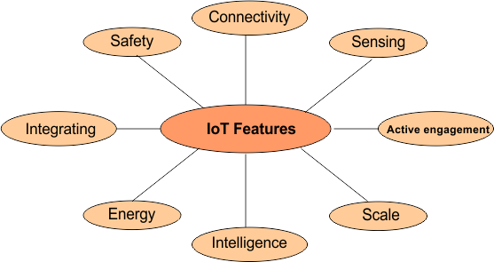
1. Connectivity (Communication)
In IoT, smart devices can communicate after connectivity. Connectivity is required in-between all the things of IoT to IoT platform. IoT platform may be server or cloud. After connecting the IoT smart devices, it’s require high speed data transfer in-between the devices and cloud. So, to achieve the reliable, secure and bi-directional communication we use Radio waves (RFID), Bluetooth, Wi-Fi or GPS technology.
2. Sensing
In IoT, the smart devices are capable to sense the data continuously. Sense of data means to detect and measure any change in the environment and report as well. Without sensing the environment IoT is incomplete. We use pressure, Electrochemical, light sensors, GPS, Electrochemical, RFID, etc. to gather data from those environment where a particular problem happens.
3. Active Engagements
IoT device connects various products, cross-platform technologies and services work together by establishing an active engagement between them. Active engagements mean sharing the sensing data among all smart devices which are connected with each other by using a technology (i.e WiFi). So, Active engagements is achieved through IoT.
4. Scale
Scaling means Flexibility. So, in IoT devices there must be flexibility so that they can be scaled up or down easily on demand. An IoT device designer should design their IoT infrastructure according to current and future scale requirement. In general, IoT is being used from smart home to large factories and work stations as well. So there must be scalability in IoT device to fulfill the needs.
5. Integrating
IoT integrating the various models to improve the user experience as well.
6. Intelligence
Artificial intelligence plays a growing role in IoT applications. Now Major vendors of IoT devices are adding the functionality of integrated AI. In a future there may be a rare case where AI is not implemented with IoT. AI minimize the human interaction where are mostly designs are made by machine such as machine learning-based analytics.
Examples of Real World where AI Embedded IoT Devices are Self- Driving Cars, Smart Homes, Body Sensors, Robots for Manufacturing Industries
7. Energy
While designing IoT ecosystems (sensors, Devices, Server etc) there is basic need to provide energy to each component of IoT ecosystem. So, Design ecosystems in such a way that it utilize minimum energy. Mostly less in size device consume less energy as compare to large size devices
8. Safety
No doubt the safety of IoT system is not good enough as compare to conventional Network. The reason is, there are many components are interconnected in IoT ecosystems to communicate with each other. By Compromising at any component of an IoT ecosystem may leads to failure of the whole pipeline. So, there must provide a proper security while designing IoT ecosystems.

4.6 IoT Components
We all have heard about Internet of Things, IoT is a transformation process of connecting our smart devices and objects to network to perform efficiently and access remotely. The major components of Internet of Things are explained below:
- Smart devices and sensors
- Gateway
- Cloud
- Analytics
- User interface
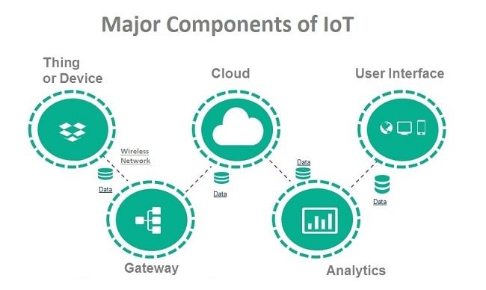

- Smart devices and Sensors
Devices and sensors are the components of the device connectivity layer. These smart sensors are continuously collecting data from the environment and transmit the information to the next layer. Latest techniques in the semiconductor technology is capable of producing micro smart sensors for various applications.
Common sensors are:
- Temperature sensors and thermostats
- Pressure sensors
- Humidity / Moisture level
- Light intensity detectors
- Moisture sensors
- RFID tags
Most of the modern smart devices and sensors can be connected to low power wireless networks like Wi-Fi, ZigBee, Bluetooth, Z-wave, etc. Each of these wireless technologies has its own pros and cons in terms of power, data transfer rate and overall efficiency.
- Gateway
IoT Gateway manages the bidirectional data traffic between different networks and protocols. Another function of gateway is to translate different network protocols and make sure interoperability of the connected devices and sensors. Gateways can be configured to perform pre-processing of the collected data from thousands of sensors locally before transmitting it to the next stage. It acts as a middle layer between devices and cloud to protect the system from malicious attacks and unauthorized access.
- Cloud
Internet of things creates massive data from devices, applications and users which has to be managed in an efficient way. IoT cloud offers tools to collect, process, manage and store huge amount of data in real time. Industries and services can easily access these data remotely and make critical decisions when necessary. Basically, IoT cloud is a sophisticated high performance network of servers optimized to perform high speed data processing of billions of devices, traffic management and deliver accurate analytics. Distributed database management systems are one of the most important components of IoT cloud. Cloud system integrates billions of devices, sensors, gateways, protocols, data storage and provides predictive analytics. Companies use these analytics data for improvement of products and services, preventive measures for certain steps and build their new business model accurately.
- Analytics
Analytics is the process of converting analog data from billions of smart devices and sensors into useful insights which can be interpreted and used for detailed analysis. Smart analytics solutions are inevitable for IoT system for management and improvement of the entire system. One of the major advantages of an efficient IoT system is real time smart analytics which helps engineers to find out irregularities in the collected data and act fast to prevent an undesired scenario. Service providers can prepare for further steps if the information is collected accurately at the right time. Big enterprises use the massive data collected from IoT devices and utilize the insights for their future business opportunities. Careful analysis will help organizations to predict trends in the market and plan ahead for a successful implementation. Information is very significant in any business model and predictive analysis ensures success in concerned area of business line.

- User Interface
User interfaces are the visible, tangible part of the IoT system which can be accessible by users. Designers will have to make sure a well-designed user interface for minimum effort for users and encourage more interactions. Modern technology offers much interactive design to ease complex tasks into simple touch panels controls. Multicolor touch panels have replaced hard switches in our household appliances and the trend is increasing for almost every smart home devices. User interface design has higher significance in today’s competitive market, it often determines the user whether to choose a particular device or appliance. Users will be interested to buy new devices or smart gadgets if it is very user friendly and compatible with common wireless standards.

4.7 Types of IoT Wireless Networks
In this topic we’ll walk through the six most common types of IoT wireless technologies. Each solution has its strengths and weaknesses in various network criteria and is therefore best-suited for different IoT use cases.

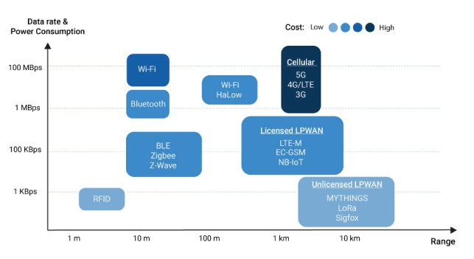
FIG: Graph of different wireless network
1. LPWANs
Low Power Wide Area Networks (LPWANs) are the new phenomenon in IoT. By providing long-range communication on small, inexpensive batteries that last for years, this family of technologies is purpose-built to support large-scale IoT networks sprawling over vast industrial and commercial sites.
LPWANs can literally connect all types of IoT sensors – facilitating numerous applications from asset tracking, environmental monitoring and facility management to occupancy. Nevertheless, LPWANs can only send small blocks of data at a low rate, and therefore are better suited for use cases that don’t require high bandwidth and are not time-sensitive. Also, not all LPWANs are created equal. Today, there exist technologies operating in both the licensed (NB-IoT, LTE-M) and unlicensed (e.g. MYTHINGS, LoRa, Sigfox etc.) spectrum with varying degrees of performance in key network factors.

2. Cellular (3G/4G/5G)
Well-established in the consumer mobile market, cellular networks offer reliable broadband communication supporting various voice calls and video streaming applications. On the downside, they impose very high operational costs and power requirements.
While cellular networks are not viable for the majority of IoT applications powered by battery-operated sensor networks, they fit well in specific use cases such as connected cars or fleet (marine) management in transportation and logistics. For example, in-car infotainment, traffic routing, advanced driver assistance systems (ADAS) alongside fleet telematics and tracking services can all rely on the ubiquitous and high bandwidth cellular connectivity.
Cellular next-gen 5G with high-speed mobility support and ultra-low latency is positioned to be the future of autonomous vehicles and augmented reality. 5G is also expected to enable real-time video surveillance for public safety, real-time mobile delivery of medical data sets for connected health, etc.
3. Zigbee and Other Mesh Protocols
Zigbee is a short-range, low-power, wireless standard (IEEE 802.15.4), commonly deployed in mesh topology to extend coverage by relaying sensor data over multiple sensor nodes. Compared to LPWAN, Zigbee provides higher data rates, but at the same time, much less power-efficiency due to mesh configuration.
Because of their physical short-range (< 100m), Zigbee and similar mesh protocols (e.g. Z-Wave, Thread etc.) are best-suited for medium-range IoT applications. Typically, Zigbee is a perfect for various home automation use cases like smart lighting, security and energy management, etc. Nevertheless, they are far from ideal for many industrial facilities that are geographically dispersed, and their theoretical scalability is often inhibited by increasingly complex network setup and management.
- Bluetooth and BLE (Bluetooth Low Energy)
Defined in the category of Wireless Personal Area Networks, Bluetooth is a short-range communication technology well-positioned in the consumer marketplace. Bluetooth Classic was originally intended for point-to-point or point-to-multipoint (up to seven slave nodes) data exchange among consumer devices.
Improved for power consumption, Bluetooth Low-Energy was later introduced to address small-scale Consumer IoT applications. BLE-enabled devices are mostly used in conjunction with electronic devices, typically smartphones that serve as a hub for transferring data to the cloud. Nowadays, BLE is widely integrated into fitness and medical wearables. (E.g. smart watches, glucose meters, pulse oximeters, etc.) as well as Smart Home devices (e.g. door locks) – whereby data is conveniently communicated to and visualized on smartphones.
5. Wi-Fi
There is virtually no need to explain Wi-Fi, given its critical role in providing high-throughput data transfer for both enterprise and home environments. However, in the IoT space, its major limitations in coverage, scalability and power consumption make the technology much less prevalent (dominant).
Imposing high energy requirements, Wi-Fi is often not a feasible solution for large networks of battery-operated IoT sensors, especially in industrial IoT and smart building scenarios. Instead, it more pertains to connecting devices that can be conveniently connected to a power outlet like smart home gadgets and appliances, or security cameras.
6. RFID
Radio Frequency Identification (RFID) uses radio waves to transmit small amounts of data from an RFID tag to a reader within a very short distance. Till now, the technology has facilitated a major revolution in retail and logistics.
By attaching an RFID tag to all sorts of products and equipment, businesses can track their inventory and assets in real-time – allowing for better stock and production planning as well as optimized supply chain management. Alongside increasing IoT adoption, RFID continues to be entrenched in the retail sector, enabling new IoT applications like smart shelves, self-checkout, and smart mirrors.
Table of application of different wireless network in different sector/ product
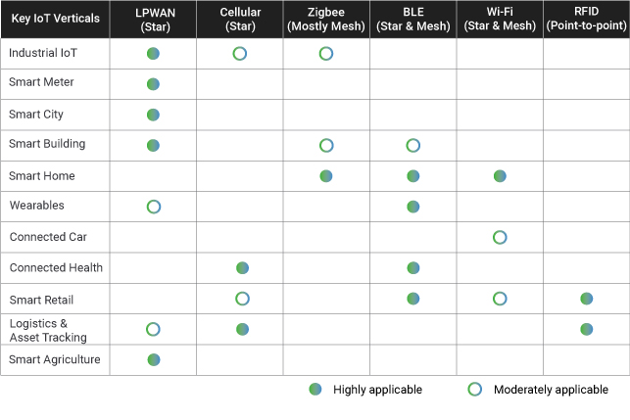
Conclusion:
To quickly sum up, each IoT vertical and application has its own unique set of network requirements. Choosing the best wireless technology for your IoT use case means accurately weighing criteria in terms of range, bandwidth, security, power consumption, and network management.

